Effects of fuel composition on the minimum ignition energy and its transition for homogeneous biogas-air mixtures

V. Papapostolou¹, C. Turquand d’Auzay¹, S.F. Ahmed², N. Chakraborty¹
¹ School of Engineering, Newcastle University, Newcastle-Upon-Tyne NE1 7RU, United Kingdom
²Department of Mechanical and Industrial Engineering, College of Engineering,
Qatar University, P. O. Box 2713, Doha, Qatar
Abstract
The minimum ignition energy (MIE) requirements for ensuring successful ignition, and self-sustained flame propagation following external energy deposition have been analysed for the forced ignition of a homogeneous stoichiometric biogas-air mixture for a wide range of initial turbulence intensities and $CO_{2}$dilutions using three-dimensional Direct Numerical Simulations (DNS) under decaying turbulence. The biogas is represented by a methane-carbon dioxide fuel blend, and the amount of carbon dioxide present in the fuel blend has been varied so it is comparable to those encountered in industrial settings. The present study illustrates that an increase in $CO_{2}$ dilution has a significant adverse effect on the ignition, due to the heatsink effect of $CO_{2}$. The variation of the MIE normalized by its respective laminar value with root-mean-square turbulent velocity fluctuation exhibits self-similar behaviour irrespective of the level of $CO_{2}$ dilution.

Introduction
Localised forced ignition (e.g. spark or laser ignition) of homogeneous mixtures is of critical importance for the efficient use of fuel in Spark Ignition (SI) engines and industrial gas turbines. The eco-friendly alternative renewable fuels are becoming ever more important because of limited reserves of conventional fossil fuels. One such alternative fuel is biogas, which can be used as either a complement or a replacement for existing fossil fuels. Biogas is primarily composed of methane ($CH_{4}$) and carbon dioxide ($CO_{2}$). The composition of biogas is off critical importance, as large variations in $CO_{2}$ content can affect ignition, leading to adverse effects on the subsequent flame propagation.
Due to the fundamental importance of localised forced ignition, a number of experimental [1-4] and computational [5,6] studies have investigated this phenomenon. In-depth experimental studies by Shy et al. [1] analysed the minimum ignition energy (MIE) for homogeneous methane-air mixtures under homogeneous isotropic forced turbulence, across varying equivalence ratios and turbulence intensities, $u^{'}/s_{l}^{0}$ (where $u^{'}$ is the root-mean-square (rms) value of turbulent velocity fluctuations, and $s_{l}^{0}$ is the unstrained laminar burning velocity). A transition in the increase of the MIE with increasing turbulence intensity was observed at a critical value $u_{c}^{'}/s_{l}^{0}$. For $u^{'}/s_{l}^{0}<u_{c}^{'}/s_{l}^{0}$ the MIE requirement increases gradually and is significantly smaller than the MIE for $u^{'}/s_{l}^{0}>u_{c}^{'}/s_{l}^{0}$, where the MIE requirement increases rapidly with increasing $u^{'}$, for $u^{'}/s_{l}^{0}>u_{c}^{'}/s_{l}^{0}$ and this transition has been justified based on scaling arguments presented by Shy et al. [1] and Turquand d’Auzay et al. [6]. Subsequently, more recent experimental studies by Cardin et al. [2] have investigated MIE variation using laser ignition for lean methane-air mixtures under isotropic homogeneous decaying turbulence, and observed a similar behaviour and transition of the MIE, that Shy et al. [1] observed using a spark ignition system. Thus, it can be inferred that the behaviour and transition of the MIE is independent of the ignition system and fuel used. Larsson et al. [3] experimentally investigated the MIE required for successful ignition for methane and propane mixtures separately diluted with nitrogen and carbon dioxide, with a view towards finding the maximum amount of inert gas concentration in a given gas composition which could be successfully ignited. The turbulence and spark characteristics where kept unaltered across all the experiments carried out and it was observed that as the volumetric percentage of diluent ($CO_{2}$) in the fuel blend increased, so did the MIE for the biogas mixture. It was found that successful ignition was possible up to a maximum of 25% carbon dioxide volumetric dilution in the fuel blend (CH₄+CO₂). Galmiche et al. [4] investigated the effects of carbon dioxide dilution (5-40% by volume) on localised forced ignition, and reported that the carbon dioxide acted as a heat sink, and an increase in the amount of $CO_{2}$ present in the mixture, leads to an increase of the energy required for a successful ignition. It was also observed that biogas-air mixtures show a slower combustion process when compared to methane-air mixtures, which is attributed to the lower burning velocity of biogas-air mixtures.
Three-dimensional Direct Numerical Simulations where utilized to analyse the early stages of premixed flame kernel development, stemming from localized forced ignition [5,6]. The negative effects of turbulence intensity in regards to successful ignition have been numerically replicated by Turquand d’Auzay et al. [6], and it was reported that an increase of turbulence intensity with a fixed length scale has a detrimental effect on successful ignition. An in-depth review on localised forced ignition for both homogeneous and inhomogeneous mixtures was published by Mastorakos [7,8], and interested readers are directed there for further information. Of particular interest to this study is the transition of MIE from low to high turbulence intensities observed across a wide range of fuels, that was reported by Shy et al. [1] and Cardin et al. [2], and was subsequently numerically replicated by Turquand d’Auzay et al. [6] for premixed stoichiometric methane-air mixtures under decaying homogeneous isotropic turbulence. To the best of the authors knowledge, the MIE variation dependent on volumetric percentage of diluent present in compound fuels such as biogas has not been investigated. The present study aims to address this gap in the existing literature by utilising three-dimensional compressible DNS to investigate the variation of the MIE for premixed stoichiometric homogeneous $CH_{4}-CO_{2}-air$ mixtures under decaying isotropic turbulence, with varying levels of $CO_{2}$ dilution. The MIE has been evaluated for, solely a successful ignition and also a successful ignition followed by self-sustained combustion once the ignitor has been switched off. Thus, the objectives of the present study are to understand the effects that varying levels of dilution of the fuel with $CO_{2}$ have on the variation of the MIE requirements for successful ignition and for subsequent flame propagation under different initial intensities of homogeneous isotropic decaying turbulence for different levels of $CO_{2}$ dilution.

Mathematical Backgound
The combustion of biogas can be represented by the following global equation:
$$CH_{4}+2\left(O_{2}+3.76N_{2}\right)+a⋅Diluent→$$
$CO_{2}+2H_{2}O+7.52N_{2}+ a⋅Diluent$ (1)
where the diluent is taken to be $CO_{2}$ for the present work. The biogas composition is described following the definition presented by Galmiche et al. [4] as $ψ^{u}=a/(a+10.52)$ where $ψ^{u}$ represents the dilution percentage which is the molar fraction of the diluent ($CO_{2}$) in the unburned gases. To account for the presence of $CO_{2}$ and in the interest of computational economy, a two-step chemical mechanism presented by Westbrook and Dryer [9] has been used for the present analysis. The chemical mechanism used, accounts for 6 species ($CH_{4}, O_{2}, CO_{2}, H_{2}O, CO$ and $N_{2}$) and is a compromise between single-step chemistry and more complex mechanisms. The above chemical mechanism has been validated for both $CH_{4}$ and $CH_{4}+CO_{2}$ mixtures, against other chemical mechanisms (GRI-Mech 3.0 [10] and 2s_CM2 [11]) and experimental results [4], and for further details regarding the performance and validation of the mechanism, interested readers are directed to recent work by Turquand d’Auzay et al. [5]. It must be mentioned that the present chemical mechanism overestimates the flame speed for all values of $ψ^{u}$, which is not expected to affect the ignition phenomenon, but is expected to have minor implications on subsequent self-sustained propagation, and thus the present study has limited itself to an intermediate level of diffusion, with $ψ^{u}≤0.10$, for which flame speed predictions are sufficiently accurate [5].
In line with previous studies [5-8] on localised forced ignition, several assumptions are made for the present study. All species in the gaseous phase are taken to be ideal gases, and thus the ideal gas law is used for compressible flow DNS. Standard values were taken for the ratio of specific heats ($γ=C_{P}^{g}/C_{v}^{g}=1.4$, where $C_{p}^{g}$ and $C_{v}^{g}$ are the gaseous specific heats at constant pressure and volume, respectively) and Prandtl number ($Pr=μC_{p}^{g}/λ=0.7$, where $μ$ is the dynamic viscosity and $λ$ is the thermal conductivity of the gaseous phase). The species diffusion velocity is accounted for by using Fick’s law of diffusion, where the transport properties are similar and independent of temperature across all species. To account for the effects of the localised forced ignition, an additional source term, $(q''' = A_{sp} exp(-r^{2}/2R_{sp}^{2})$ with $r$ being the distance from the ignitor centre and $R_{sp}$ representing the characteristic width of energy deposition) is added to the energy conservation equation, which follows a Gaussian distribution in the radial direction from the ignition centre [5-8]. The constant $A_{sp}$ is determined by a volume integration which leads to the total ignition power $\dot{Q}$ given by [5-8]:$\dot{Q}=\int_{V}{q''' dV}= a_{sp} ρ_{0}C_{p}τ T_{0}\left(\frac{4}{3}π {δ_{z}^{0}}^{3}\right)\left[H\left(t\right)-H\left(t-t_{sp}\right) \right]/t_{sp}$where $a_{sp}$ is a parameter determining the total energy deposited by the ignitor, $τ = (T_{ad}^{0}-T_{0})/T_{0}$is the heat release parameter (where $T_{ad}^{0}$ and $T_{0}$ are the adiabatic flame temperature of the undiluted stoichiometric mixture and unburned gas temperature respectively), $δ_{z}^{0}$ is the Zel'dovich flame thickness of the undiluted stoichiometric mixture ($δ_{z}^{0} = D_{0}/s_{l}^{0}$, where $D_{0}$ is the unburned mass diffusivity of the reactants) and $H\left(t\right)$, and $H\left(t-t_{sp}\right)$ are Heaviside functions, which ensure that the ignitor is only active until $t = t_{sp}$. The energy deposition duration $t_{sp}$, is expressed as $t_{sp} = b_{sp}t_{f}$, where $t_{f} = δ_{z}^{0}/s_{l}^{0}$ is a characteristic timescale and the energy deposition parameter $b_{sp}$ is given a value of $b_{sp} = 0.2$ in the present study, which falls within its optimal range ($0.2≤b_{sp}≤0.4$) [5-8]. The details of the spark formation (momentum modification contribution, plasma and shock wave formation) are not considered in this analysis for the purpose of simplicity and computational economy. In the present study, $b_{sp}$ and $R_{sp}$ are kept constant (i.e. $b_{sp}=0.2$, $R_{sp}=2.45δ_{z}^{0}$) whilst $a_{sp}$ is varied until the minimum energy levels leading to either of the two following phenomena are found:
1. Ignition - A successful ignition refers to a situation where the maximum temperature surpasses the adiabatic flame temperature ($T_{ad}^{ψ}$) during or after the energy deposition period regardless of subsequent flame behaviour. If the maximum temperature does not reach the adiabatic flame temperature, it is referred to as a misfire in the following discussion.
2. Self-sustained propagation - A successful self-sustained propagation is obtained when the flame kernel burns without the aid of the ignitor after a successful ignition. It is determined by evaluating the temporal evolution of the burned gas volume, that is, if the temporal derivative is positive at the end of the simulation time.

Numerical Implementation
The simulations have been carried out using the three-dimensional compressible DNS code SENGA+ [5,6] in two separately sized domains depending on whether the MIE for either ignition or propagation was being determined. For ignition across all turbulence intensities investigated, the computational domain is taken to be 44$δ_{z}^{0}×44δ_{z}^{0}×44δ_{z}^{0}$ or $4.8l_{t}×4.8l_{t}×4.8l_{t}$, and subsequently when self-sustained propagation was investigated a larger domain of 66$δ_{z}^{0}×66δ_{z}^{0}×66δ_{z}^{0}$ or $7.4l_{t}×7.4l_{t}×7.4l_{t}$ was used. The domain sizes have been chosen in such a manner to accommodate the development of the kernel in the computational domain for as long as possible. The domains are discretized by Cartesian grids of 352$×352×352$and $540×540×540$, respectively, with cells of uniform size$Δx$, which ensures 10 grid points across the undiluted thermal flame thickness $δ_{th}^{0} ={\left[T_{ad}^{0}- T_{0}\right]}/{max\left({\left|∇ \hat{T}\right|}_{L}\right)}<δ_{th}^{ψ^{u}}$. It also ensures $η_{k} >Δx$, where $η_{k}$ is the Kolmogorov length scale. The spatial differentiation and time advancements have been carried out using high order finite difference and explicit Runge-Kutta schemes respectively [5,6]. The flame-turbulence interaction takes place under decaying isotropic homogeneous turbulence. A well-known pseudo-spectral method is used to initialise the turbulent velocity fluctuation by an incompressible, homogeneous isotropic field with prescribed values of root-mean-square (rms) values ($u^{'}$) and integral length scale ($l_{t}$). The initial integral length scale is kept constant throughout the study at $l_{t}/δ_{z}^{0}=9$, and it remains comparable with previous computational studies of localised ignition [5,6].

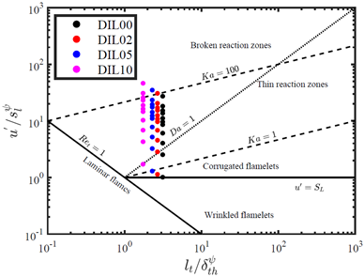
Figure 1. The cases investigated here on the regime diagram. The cases with $ψ^{u}=0.025,0.05$ and $0.10$ are shown by black, red, blue and magenta points.

The present study investigates the ignition phenomenon across three separate levels of dilution $ψ^{u}=0.025,0.05$ and $0.10$, which for brevity are referred to as DIL02, DIL05 and DIL10, respectively. The mixture across all cases investigated remains perfectly premixed and stoichiometric and the initial mass fractions of oxidizer, methane and carbon dioxide can be recovered for each dilution percentage investigated from the definition of $ψ^{u}$ in conjunction with Eq. 1. Figure 1 shows all the cases investigated in the present study on the regime diagram. Additionally, the cases investigated by a previous computational study [5] on the forced ignition of undiluted stoichiometric methane-air mixtures, are included to allow for comparisons between the studies. The ratio $l_{t}/δ_{z}^{0}$ is kept constant, however when the respective diluted mixture value $δ_{z}^{ψ}$ is used, the ratio $l_{t}/δ_{z}^{ψ}$ decreases with increasing dilution percentage as shown in Fig. 1, as the presence of $CO_{2}$ thickens the flame.

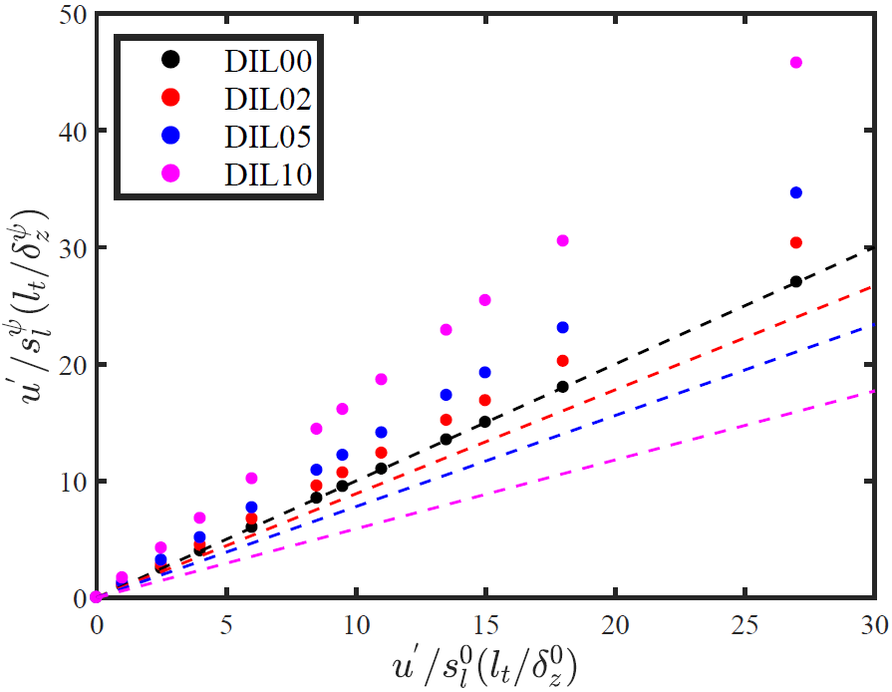
Figure 2. - Variation of $u^{'}/s_{l}^{ψ}$ with $u^{'}/s_{l}^{0}$ (dots), and variation of $l_{t}/δ_{z}^{ψ}$ with $l_{t}/δ_{z}^{0}$ (lines), across all cases investigated.

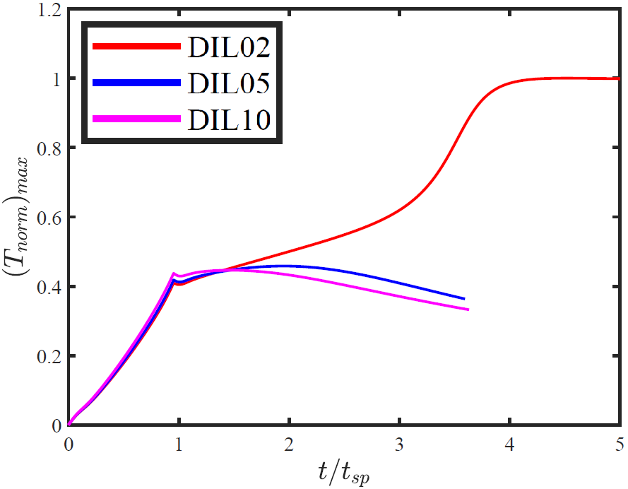
Figure 3. Temporal evolutions of the maximum value of $T_{norm}$ under laminar conditions with $ψ^{u}=0.025, 0.05$ and $0.10$ as indicated by the legend for an input energy equal to the MIE for $ψ^{u}=0.025$ under laminar conditions.

The cases investigated here were set up to mimic combustion occurring in a combustion chamber of a gas turbine, where the initial turbulence intensity ($u'$) is determined beforehand and subsequently remains unaltered, whilst the level of dilution in the fuel is subject to change, due to the difficulty of producing industrial quantities of biogas with fixed composition ($ψ^{u}$), and this approach is consistent with the experimental work by Larsson et al [3]. This in turn means that even as $u'$ and $l_{t}$ are kept constant, as the mixture composition varies, the ratios of $u^{'}/s_{l}^{ψ}$ and $l_{t}/δ_{th}^{ψ}$ vary as shown in Fig. 2, and this has a significant effect on ignition and subsequent flame behaviour. The DNS simulations, which are used to evaluate the MIE only for successful ignition, have been carried out for at least $t=2t_{sp}$, whilst the simulations for successful propagation, have been carried out till $t=10t_{sp}$, or until the kernel exits the domain. For each turbulence intensity across all dilution percentages investigated, multiple simulations have been carried out with different values of the ignition energy parameter $a_{sp}$ to estimate the MIE to a precision of about 1% of the corresponding diluted laminar MIE value for ignition, whilst for propagation the MIE was sought with an accuracy of 2-4% of the corresponding diluted laminar MIE value.
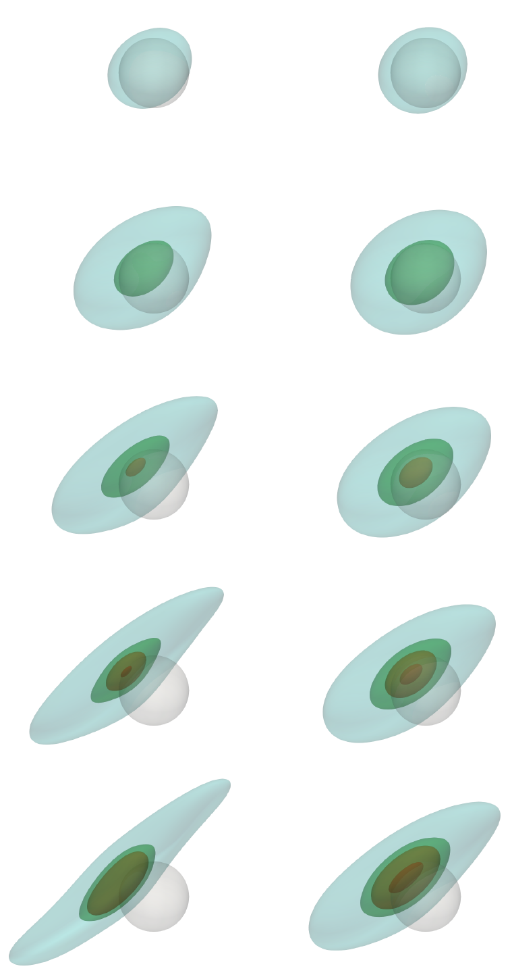
$$T_{norm}=0.1$$
$$T_{norm}=0.3$$
$$T_{norm}=0.5$$
$$T_{norm}=1.0$$
Energy deposition region
Figure 4. Isosurfaces of (grey) $T_{norm}=0.1$, (green) $0.3$, (orange), $0.5$ and (red) $1.0$ with the energy deposition region indicated by the translucent red sphere, obtained for ${\left(Γ_{MIE}^{ψ^{u}}\right)}_{i}$ with $u^{'}/s_{l}^{ψ}≈10.50$ for $ψ^{u}=0.025$ (left column) and $ψ^{u}=0.10$ (right column). Kernels are shown at $t/t_{sp}=0.5, 1.0, 1.5, 2.0, 2.5$ (top to bottom).

Results and Discussion
To understand the effect that varying levels off dilution have on the ignition phenomenon, it is instructive to examine the temperature profiles under laminar conditions across the different dilution levels investigated. To illustrate the effects of increasing $ψ^{u}$, the temporal evolutions of the maximum value of $T_{norm}=(\hat{T}-T_{0})/(T_{ad}^{ψ}-T_{0})$ under laminar conditions for three dilution percentages are shown in Fig. 2 for an input ignition energy which is the MIE for $ψ^{u}=0.025$ An increase of $ψ^{u}$ leads to a decrease in the maximum value of $T_{norm}$. It can be seen from Fig. 2 that thermal runaway takes place only for $ψ^{u}=0.025$, and the maximum value of $T_{norm}$ surpasses its value corresponding to the respective adiabatic flame temperature ($T_{norm}>1.0$) at $t/t_{sp}=4.0$, whilst for the other dilution percentages $T_{norm}$ decreases after the end of the energy deposition duration ($t/t_{sp}=1.0$), and results in a failed ignition. The temporal evolution of $(T_{norm})_{max}$ for the case with $ψ^{u}=0.025$ in Fig. 3 is indicative of an auto-ignition, as the thermal runaway happens after the end of energy deposition duration, and this behavior is consistent with previous findings [6]. Due to all three different cases being laminar and identical energy being deposited into the mixture, as expected a higher $ψ^{u}$ can lead to unsuccessful ignition, highlighting the ‘heat sink effect’ of $CO_{2}$ which is also consistent with a recent computational analysis by Turquand d’Auzay et al. [5]. This in turn suggests that the MIE requirement increases as $ψ^{u}$ increases whilst $u^{'}/s_{l}^{0}$is constant, and this has been observed by the present study and is discussed later in this paper. Thermal runaway due to autoignition after the energy deposition period has also been observed for the MIE corresponding to $ψ^{u}=0.05$ and $0.10$ under laminar conditions, and the temporal evolutions of $(T_{norm})_{max}$ for the MIE for $ψ^{u}=0.05$ and $0.10$ are qualitatively similart to the profile shown for $ψ^{u}=0.025$ in Fig. 3. It is also worth mentioning how the time delay ($≈4t_{sp}$) for $(T_{norm})_{max}$ to surpass the adiabatic flame temperature (i.e. $T_{norm}=1.0$) for the case shown in Fig. 3, is nearly double in comparison to the time delay observed for undiluted methane air mixtures ($≈2.3t_{sp}$) under identical conditions (see Fig. 5a from [6]). This illustrates the detrimental effects of $CO_{2}$dilution on successful ignition, along with the slower combustion process that arises when compared to undiluted methane-air mixtures, which is in agreement with experimental studies [4].
To further investigate the effects of varying $ψ^{u}$ on ignition in conjunction with initial turbulence intensity, isosurfaces of different values of $T_{norm}$ at $t/t_{sp}=0.5,1.0,1.5,2.0,2.5$ are presented in Fig. 4. Two cases with almost identical $u^{'}/s_{l}^{ψ} (≈10.50)$ with $ψ^{u}=0.025$ and $0.10$ were chosen for the purpose of comparison. From Fig. 2 it can be seen that despite $u^{'}/s_{l}^{ψ}$ being nearly the same, for the case with $ψ^{u}=0.025$ it corresponds to $u^{'}/s_{l}^{0}=9.5$, whilst for $ψ^{u}=0.10$ it amounts to $u^{'}/s_{l}^{0}=6.0$. Previous studies have shown that a higher $u^{'}/s_{l}^{0}$ has an adverse effect on ignition [1,2,6-8,12,13]. Observing the temporal evolution of the $T_{norm}$ isosurfaces shown in Fig. 4, it can be seen that despite $u^{'}/s_{l}^{ψ}$ being very similar, the ignition kernel with $ψ^{u}=0.025$ is significantly more wrinkled and elongated due to turbulence than the corresponding $ψ^{u}=0.10$ case. At $t=2.0t_{sp}$, both cases have achieved successful ignition as an isosurface of $T_{norm}=1.0$ can be seen. However, at $t=2.5t_{sp}$ for the case with $ψ^{u}=0.025$, the kernel is quenching as the $T_{norm}=1.0$ isosurface is not present anymore, whilst for the case with $ψ^{u}=0.10$ the $T_{norm}=1.0$ isosurface is growing, indicating combustion is continuing at that stage. This result is superficially counter-intuitive but it is important to also account for the level of energy deposited. In order to allow for direct comparison between cases with different dilution percentages, the MIE is normalised based on the MIE obtained for the respective $ψ^{u}$ under laminar conditions, and is calculated as${\left(Γ_{MIE}^{ψ^{u}}\right)}_{i}=MIE^{ψ^{u}}/MIE_{0}^{ψ^{u}}$, where the superscript $ψ^{u}$ indicates a constant dilution level, whilst the subscript $0$ indicates laminar conditions. For the case with $ψ^{u}=0.025$, $Γ_{MIE}^{ψ^{u}}$ is 1.085 (i.e. ${\left(Γ_{MIE}^{ψ^{u}}\right)}_{i}=1.085$), whilst ${\left(Γ_{MIE}^{ψ^{u}}\right)}_{i}=1.025$ is obtained for the case with $ψ^{u}=0.10.$ the $MIE_{0}^{ψ^{u}}$for the $ψ^{u}=0.10$ case is comparable to that in the $ψ^{u}=0.025$case (e.g.${MIE_{0}^{ψ^{u}}}/{{[ρ}_{0}\left({4π{δ_{z}^{0}}^{3}}/{3{)C}_{p}\left(T_{ad}^{0}-T_{0}\right)}\right]}=3.85$ and 3.90 for $ψ^{u}=0.025$ and 0.10 respectively).
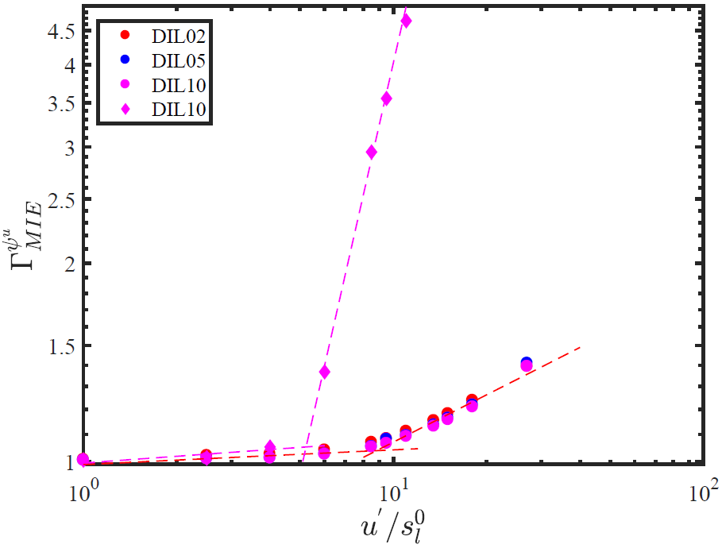
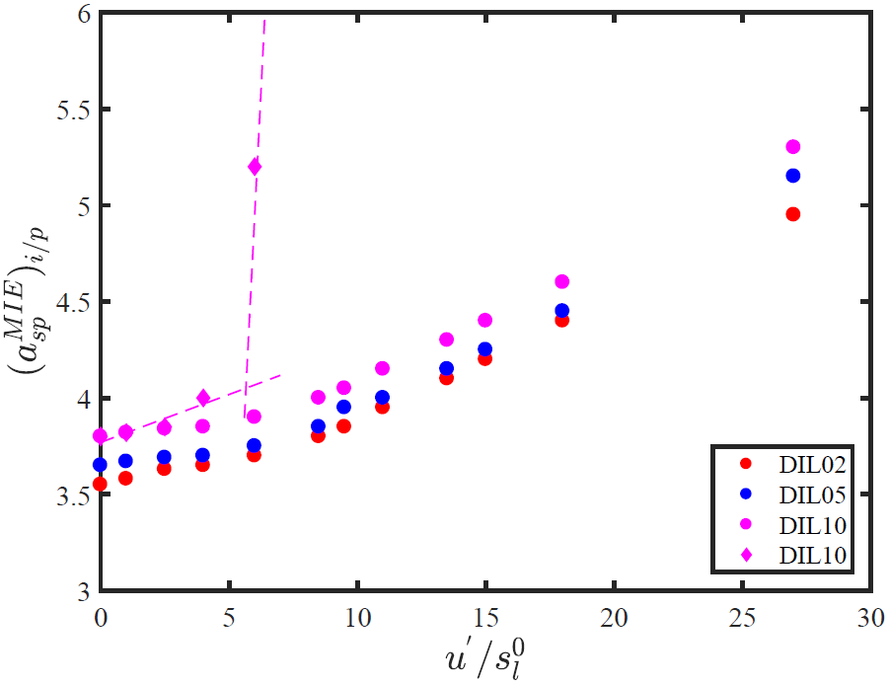
Propagation
$Γ_{MIE}^{ψ^{u}}∝{\left(\frac{u^{'}}{s_{l}^{0}}\right)}^{2}$
Ignition $Γ_{MIE}∝{\left(\frac{u^{'} }{s_{l}^{0}}\right)}^{0.24}$
Ignition & Propagation
$Γ_{MIE}^{ψ^{u}}∝{\left(\frac{u'}{s_{l}^{0}}\right)}^{0.03}$
$Γ_{MIE}∝{\left(\frac{u^{'}}{s_{l}^{0}}\right)}^{0.2}$
Figure 5. Variations of normalised MIEs (a) ${\left(a_{sp}^{MIE}\right)}_{α/p}$ (dots) and propagation (diamonds and dashed line) and (b) ${\left(Γ_{MIE}^{ψ^{u}}\right)}_{i/p}$with $u^{'}/s_{l}^{0}$.

Thus, the resulting kernel ignites and then subsequently quenches for $ψ^{u}=0.025$, whilst the case with $ψ^{u}=0.10$ exhibits successful ignition and the kernel continues to grow up to the time instant shown in Fig. 4 for almost similar ignition energy input. From the above observations, it can be surmised that although the level of CO₂ dilution in the mixture plays a significant role in whether successful ignition will occur, $u^{'}/s_{l}^{0}$ remains the dominating factor (e.g. ${u^{'}}/{s_{l}^{0}}=9.5$ and 6.0 for $ψ^{u}=0.025$ and 0.10 respectively) because an increase in $u^{'}$, for a given value of $l_{t}$ increases the eddy thermal diffusivity $D_{t}\sim u^{'}l_{t}$ and thus increases the heat transfer rate from the hot gas kernel and acts to quench (or decrease) the kernel (burning rate), as shown by previous studies [1,2,6-8,12,13]. To further investigate this effect it is instructive to examine the variations of ${\left(a_{sp}^{MIE}\right)}_{α}={{\left(MIE^{ψ^{u}}\right)}_{α}}/{{[ρ}_{0}\left({4π{δ_{z}^{0}}^{3}}/{3{)C}_{p}\left(T_{ad}^{0}-T_{0}\right)}\right]}$ and ${\left(Γ_{MIE}^{ψ^{u} }\right)}_{α}$ (with $α=i$ for successful ignition and $p$ for successful self-sustained flame propagation) as a function of $u^{'}/s_{l}^{0}$ in Fig. 5. The corresponding variations of ${\left(a_{sp}^{MIE}\right)}_{α}$ and ${\left(Γ_{MIE}^{ψ^{u} }\right)}_{α}$ as a function of $u^{'}/s_{l}^{ψ}$ are shown in Fig. 6.
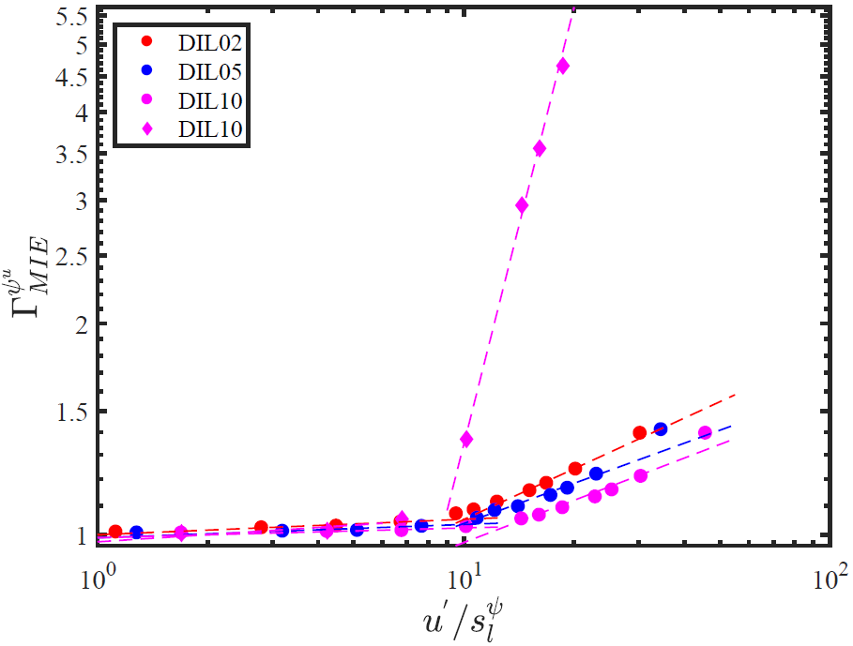
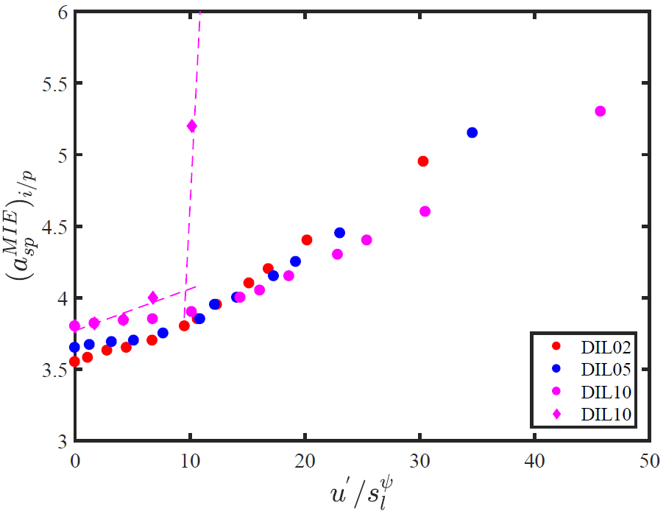
Propagation
$Γ_{MIE}^{ψ^{u}}∝{\left(\frac{u^{'}}{s_{l}^{ψ}}\right)}^{2}$
Ignition
$Γ_{MIE}∝{\left(\frac{u^{'}}{s_{l}^{ψ}}\right)}^{0.24}$
Ignition & Propagation
$Γ_{MIE}∝{\left(\frac{u^{'}}{s_{l}^{ψ}}\right)}^{0.2}$
Figure 6. Variations of normalised MIEs (a) ${\left(a_{sp}^{MIE}\right)}_{α/p}$ (dots) and propagation (diamonds and dashed line) and (b) ${\left(Γ_{MIE}^{ψ^{u}}\right)}_{i/p}$with $u^{'}/s_{l}^{ψ}$.

It can be seen from Figs. 5a that $({a_{sp}^{MIE})}_{i}$ increases with increasing $ψ^{u}$ and this behaviour is consistent for all $u^{'}/s_{l}^{0}$ . This is consistent with previous analysis [6] and observations made in the context of Fig. 3. The increase in the energy requirement with increasing $ψ^{u}$ is attributed to the ‘heat sink effect’ of $CO_{2}$, as a higher dilution level corresponds to more $CO_{2}$ in the mixture. A higher energy level is accordingly required for larger value of $ψ^{u}$ so that the heat release rate in the hot gas kernel can supersede the heat transfer rate to give rise to eventual thermal runaway in the cases of successful ignition. For a given set of initial values of $u^{'}/s_{l}^{0}$ and $l_{t}/δ_{z}^{0}$, the eddy diffusivity remains mostly unaffected by the values of $ψ^{u}$, and thus the driving factor for the higher MIE requirement is the reduction in chemical heat release rate with increasing $ψ^{u}$. Figure 5b, where $Γ_{MIE}^{ψ^{u}}$ is plotted as a function of $u^{'}/s_{l}^{0}$, which shows that $Γ_{MIE}^{ψ^{u}}$ increases with increasing $u^{'}/s_{l}^{0}$ and exhibits a transition of the MIE requirement at around $u_{c}^{'}/s_{l}^{0}=8.0$ as indicated by the trend lines. The normalised MIE requirements for self-sustained flame propagation $({a_{sp}^{MIE})}_{p}$ and ${\left(Γ_{MIE}^{ψ^{u}}\right)}_{p}$ for $ψ^{u}=0.10$ is also exemplarily shown in Figs. 5b and 6b. It can be seen from Figs 5b that ${\left(Γ_{MIE}^{ψ^{u}}\right)}_{p}$shows a transition at ${u_{c}^{'}}/{s_{l}^{0}}=6$ and the MIE requirement increases rapidly for $u^{'}/s_{l}^{0}>u_{c}^{'}/s_{l}^{0}$. However, these transitions of $({a_{sp}^{MIE})}_{p}$ and ${\left(Γ_{MIE}^{ψ^{u}}\right)}_{i}$are obtained for different values of $u^{'}/s_{l}^{ψ}$ for different values $ψ^{u}$. Moreover, the increased demand of MIE for higher value of $ψ$ is not clearly evident from Fig. 6a.
These differences arise due to the differences between the values of $u^{'}/s_{l}^{ψ}$ and $u^{'}/s_{l}^{0}$, as shown in Fig. 2 and thus two identical values of $u^{'}/s_{l}^{ψ}$ for different $ψ^{u}$ values correspond to different values of $u^{'}/s_{l}^{0}$. The variations of ${\left(Γ_{MIE}^{ψ^{u}}\right)}_{p}$ with $u^{'}/s_{l}^{0}$ and $u^{'}/s_{l}^{ψ}$ exhibit a power-law with an exponent of 2.0 for $u^{'}/s_{l}^{0}>{u_{c}^{'}}/{s_{l}^{0}}$, as shown by the trendlines in Figs. 5b and 6b. This is quantitatively consistent with previous computational findings based on undiluted stoichiometric CH₄-air mixtures [6] and the experimental results by Cardin et al. [2]. A qualitatively similar MIE (for self-sustained flame propagation) variation with turbulence intensity with much larger power-law exponent has been reported by Shy et al. [1]. The possible differences between the numerical results and findings by Shy et al. [1] have been discussed in Ref. [6] and thus are not repeated here. Turquand d-Auzay et al. [6] also explained ${\left(Γ_{MIE}^{ψ^{u}}\right)}_{p}\sim {\left({u^{'}}/{s_{l}^{0}}\right)}^{2}$ based on a scaling argument, which was in good agreement for the undiluted stoichiometric CH₄-air mixture. The present results indicate that the scaling ${\left(Γ_{MIE}^{ψ^{u}}\right)}_{p}\sim {\left({u^{'}}/{s_{l}^{0}}\right)}^{2}$ may also be valid for biogas-air mixtures. The increasing demand of the MIE with an increase in $u^{'}$ is in good qualitative agreement with both previous experimental [1,2,7,8] and computational [6,12,13] analyses. Moreover, a comparison between $({a_{sp}^{MIE})}_{p}$ and $({a_{sp}^{MIE})}_{i}$ for $ψ^{u}=0.1$ reveals that the MIE for self-sustained flame propagation is likely to be greater than the MIE for just successful ignition for $u^{'}/s_{l}^{0}>u_{c}^{'}/s_{l}^{0}$ , which is also consistent with previous findings [6] and interested readers are referred to Turquand d’Auzay et al. [6] for the relevant physical explanation. Of particular interest is the collapse of all the $Γ_{MIE}^{ψ^{u}}$ curves for the $ψ^{u}$ values investigated here into one. As outlined previously an increase of $ψ^{u}$ results in a higher energy requirement, but $ψ^{u}$ does not affect the ${\left(Γ_{MIE}^{ψ^{u}}\right)}_{i}$ variation with ${u^{'}}/{s_{l}^{0}}$, and ${\left(Γ_{MIE}^{ψ^{u}}\right)}_{i}$is solely dependent on $u^{'}/s_{l}^{0}$. This in turn implies that once the MIE for a given $ψ^{u}$ under laminar conditions is determined, it is possible to estimate the $Γ_{MIE}^{ψ^{u}}$ required for any $u^{'}/s_{l}^{0}$ following the trend line shown in Fig. 5b.

Conclusions
The minimum ignition energy (MIE) of stoichiometric biogas-air mixtures with varying levels of CO₂ dilatation have been numerically evaluated under homogeneous isotropic decaying turbulence for a wide range of initial turbulence intensities. An increase in mole fraction of CO₂ in the CH₄/CO₂ blend ($ψ^{u}$) increases the MIE demand significantly which is in good qualitative agreement with previous experimental results [4]. It was also shown that the variation of the MIE for successful ignition normalised by its respective laminar value ${\left(Γ_{MIE}^{ψ^{u}}\right)}_{i}$with $u^{'}/s_{l}^{0}$collapses into a single distribution for all levels of dilution, which allows for the MIE at a given $u^{'}/s_{l}^{0}$ to be calculated with an acceptable level of accuracy for a range of different homogeneous biogas-air mixtures. The variation of the MIE with turbulence intensity exhibits a transition such that the energy demand increases significantly above a threshold value of turbulence intensity for both successful ignition and self-sustained flame propagation. This behaviour has been found to be consistent with previous numerical [6] and experimental [1,2] findings. However the critical ${u^{'}}/{s_{l}^{ψ}}$at which the transition occurs appears to be dependent on $ψ^{u}$ but the corresponding ${u^{'}}/{s_{l}^{0}}$ value remains mostly unaffected by CO₂ dilution. The MIE for self-sustained propagation assumes considerably higher values than the MIE for only successful ignition and a scaling for the normalised MIE for self-sustained flame propagation ${\left(Γ_{MIE}^{ψ^{u}}\right)}_{p}$ for undiluted stoichiometric methane-air mixture has been found to be valid even for the stoichiometric biogas-air mixture with $ψ^{u}=0.1$. Further investigation will be necessary to analyse the possibility of the self-similar behaviours of ${\left(Γ_{MIE}^{ψ^{u}}\right)}_{p}$ with the variation of ${u^{'}}/{s_{l}^{0}}$.

Acknowledgements
The authors would like to thank the British Council, ESPRC (EP/K025163/1, EP/R029369/1) Rocket (HPC facility at Newcastle University), Cirrus and ARCHER for financial and computational support

References
[1] S.S. Shy, C.C. Liu, W. Shih, Combust. Flame 157 (2) (2010) 341–350.
[2] C. Cardin, B. Renou, G. Cabot, A.M. Boukhalfa, Comptes Rendus Mécanique 341 (1–2) (2013) 191–200.
[3] A. Larsson, A. Berg, A. Bonaldo, Proc. ASME Turbo Expo, (2013) GT2013-95536.
[4] B. Galmiche, F. Halter, F. Foucher, F., P. Dagaut, Energy Fuels, 25(3) (2011) 948–954
[5] C. Turquand d’Auzay, V. Papapostolou, S.F. Ahmed, N. Chakraborty, Combust. Sci. Technol. (2019) (accepted)
[6] C. Turquand d’Auzay, V. Papapostolou, S.F. Ahmed, N. Chakraborty, Combust. Flame, 201 (2019) 104–117.
[7] E. Mastorakos, Prog. Energy Com- bust. Sci. 35 (1) (2009) 57–97.
[8] E. Mastorakos, Proc. Combust. Inst. 36 (2) (2017) 2367–2383.
[9] C.K. Westbrook, F.L. Dryer, Combust. Sci. Technol., 27(1–2) (1981) 31–43.
[10]http://www.me.berkeley.edu/grimech/version30/text30.html (2000).
[11] J. Bibrzycki, T. Poinsot, Work. note ECCOMET WN/CFD/10/17, CERFACS (2010).
[12] D. Patel, N. Chakraborty, Int. J. Spray Combust. Dyn., 7 (2015) 151-174.
[13] D. Patel, N. Chakraborty, Int. J. Spray Combust. Dyn. 8, (2016) 183-196.

