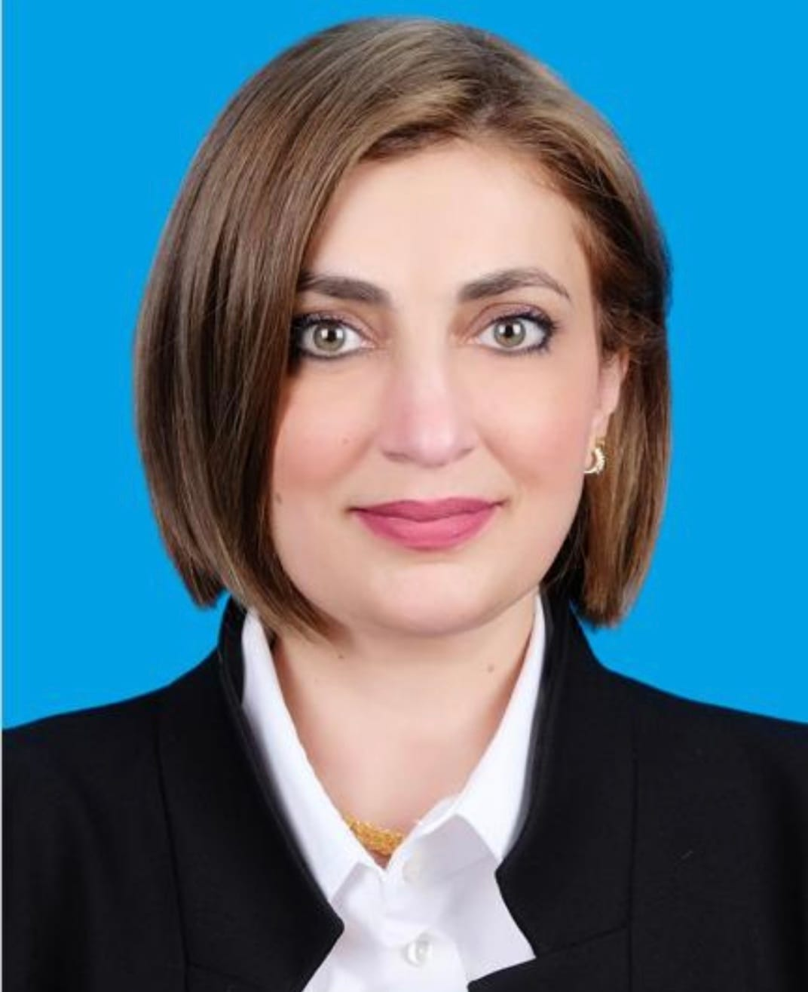
Majeda Khraisheh, PhD, CENG, FIChemE
Professor and Head of Department
Chemical Engineering, College of Engineering
Room BCR G118
Tel.:+974 4403 4993; Fax: +974 4403 4131
Mobile: +974 30999747
Qatar University
P.O. Box 2713, Doha, Qatar

Links:
Majeda Khraisheh - AD Scientific Index 2023
Majeda Khraisheh, PhD, CENG, FIChemE‬ - Google Scholar‬
Scopus - Author search results
Faculty and Staff | Qatar University (qu.edu.qa)
m.khraisheh | Just another QU Faculty Sites site

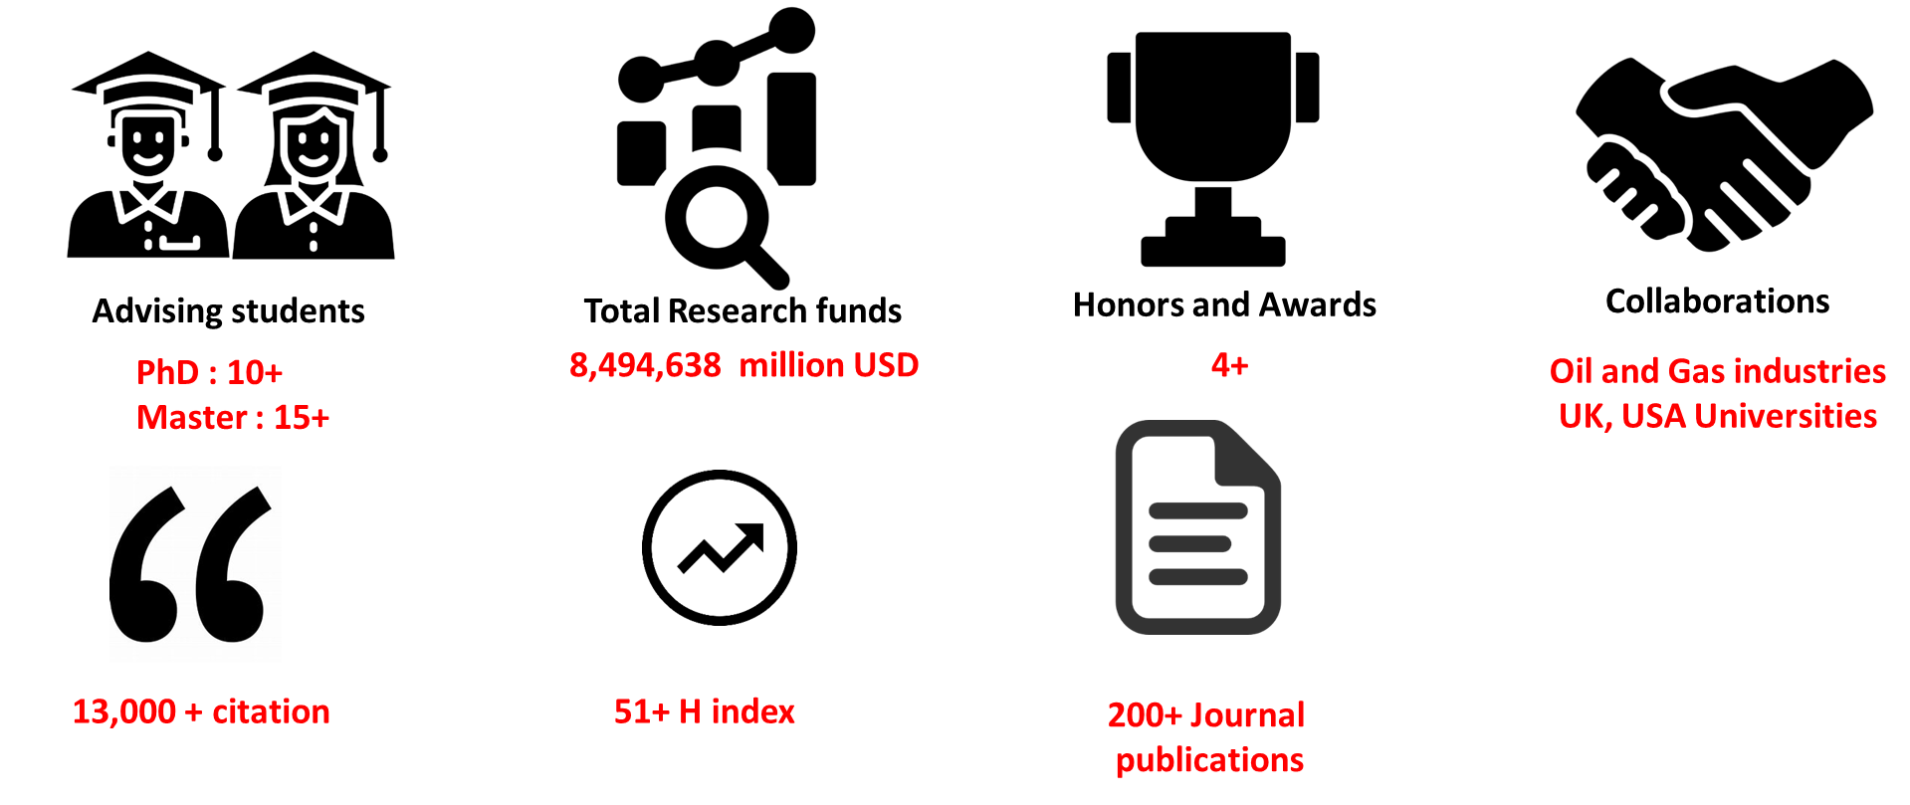

Education
2000-2002 Postgraduate Diploma in Higher Education Teaching, Queen’s University Belfast, UK.
1992-1996 Ph.D. Chemical Engineering, Queen’s University Belfast, UK.
1990-1992 BEng Chemical Engineering, Queen’s University Belfast, UK. (Honors, First class)
1988-1990 Chemical Engineering, University of Jordan, Amman, Jordan
1987-1988 General Secondary Exam- Scientific Division- Amman, Jordan

Professional History

January 2017-Present | Head Of Chemical Engineering, Qatar University
Sept 2014-Present | Professor Chemical Engineering, Qatar University
February 2009- Sept 2014 | Associate Professor of Chemical Engineering, Qatar University
Jan 2004- Feb 2009 | Associate Prof. University College London (UCL), UK
Dec 1999- Dec 2003 | Assistant Prof. Queen’s University Belfast, UK
Mar 1997- Dec 1999 | Postdoc the Queen’s University Environmental Science and Technology Research Centre (QUESTOR), Northern Ireland, UK.

Professional Memberships
2016-Present Member of AICHE, USA.
2013-Present Fellow of the Institute of Chemical Engineers UK (FICHEME)
2005- Present Chartered Engineer (CEng). UK Engineering Council.
1992-Present IChemE, Member, UK
2009- Present Jordanian Renewable energy Society, Founding member, Jordan
2011-Present Arab Renewable Energy Society Member

Main Awards, Honors and recognitions
2014 Qatar University Merit Award
2013 Leadership Excellence award Middle East, MEPEC 13, Bahrain.
2012 Qatar University Outstanding teaching award.
2012 Best paper in the 3nd International Gas Conference, Qatar Doha
2010 College of Engineering Excellence in services awards (Faculty affairs committee)
2010 College of Engineering Excellence in teaching Award for 2009-2010
2010 Best paper in the 2nd International Gas Conference, Qatar Doha
1996 The institution of Chemical Engineers prize for the best paper and presentation at the Second European Conference for Young Researchers in Chemical Engineering
1993-1995 Arab-British Award
1993-1995 Arab Student International Award
1992 Foundation Award for Best Student, Queen’s University of Belfast, N. Ireland, UK.

Consulting Experience

2017 Ministry of Municipality and Environment. Qatar, Review of Qatari Environmental laws
2014 Airport Authority Jordan- Energy and Carbon footprint reduction
2012 Ministry of Environment, Qatar (EIA review of new industrial plant)
2011 Ministry of Environment, Qatar Development of Qatar National Environmental Strategy
2010 Wool-Il ERS Ltd, Seoul, Korea (Development of Eco friendly adsorbent material)
2006 Carbon Trust, London UK (Du Diligence study)
2006 Southern Water, Kent, UK (H2S removal)
2005 Land Security, London UK (Sustainable Cleaning and microfiber cloths)
2001 John Hanna Dyers and Finishers, Northern Ireland, UK (Removal of Azo Dyes)

Professional Training
(Summary of major training courses)
Feb 2014 Middle management training (given by Broadlands consultants)- Doha Qatar
Summer 2012 NCHC Summer Institute “Honors Assessment and Evaluation” – Nebraska USA
January 2012 COSMO oil training course: Energy Saving and environmental management in oil industry in Japan- Cosmo oil Co LTD-Japan
January 2010 COSMO oil training course: Environmental sustainability - Japan-
June-Sept 2009 Industrial Training in LNG Production and Processing. Qatar Gas, Ras Lafan, Qatar.
2000-2002 Postgraduate Diploma in Higher Education Teaching, Queen’s University Belfast, UK.

Funded Projects:
Project sample:
Project number | Role | Amount $
Completed | LPI
UREP06-088-2-020 | LPI | 20,000
UREP06-133-2-030 | LPI | 30,000
NPRP09-328-2-122 | LPI | 1,043,026
NPRP 09-739-2-284 | LPI | 974,004
UREP07-046-2-011 | LPI | 49,999
UREP08-035-2-008 | LPI | 56,000
UREP10-014-2-005 | LPI | 60,000
UREP10-016-2-006 | LPI | 59,900
NPRP5-590-2-238 | LPI | 104,2319
UREP11-038-2-014 | LPI | 59,470
NPRP6-330-2-140 | LPI | 1,030,800
UREP14-055-2-015 | LPI | 60,000
NPRP7-203-2-097 | PI | 835,734
GSRA2-1-0603-14012 | LPI Mentor
NPRP8-270-2-106 | LPI | 775,102
UREP17-005-2-002 | LPI | 59,900
NPRP10-01707-170119 | LPI | 599,828
NPRP10-0126-170257 | PI | 459,848
UREP23-041-2-012 | PI | 28,750
PDRA5-0407-19003 | LPI Mentor
GSRA5-1-0524-18068 | LPI Mentor
IRCC117 | LPI | 200,000
IRCC147 | PI | 200,000
NPRP12S-0306-190247 | PI | 599,958

Teaching:

Teaching variety of undergraduate chemical engineering, general engineering and MSc level courses.

Senior Design (Plant Design) (undergraduate) | Heat Transfer(undergraduate)
Petroleum and GAs technologies(undergraduate) | Practical Industrial Training(undergraduate)
Introduction to Chemical Engineering(undergraduate) | Fluid mechanics and Heat transfer lab(undergraduate)
Water and wastewater treatment(undergraduate) | Carbon capture and utilization (graduate)
Environmental assessment and management(graduate) | Applied research methodology(graduate)
Advanced Special topics(graduate) | Environmental measurements and stat lab(graduate)
Engineering Economy (undergraduate, general engineering) | Numerical methods (undergraduate, general engineering)

Publications:
A complete list of publications can be found in:
Majeda Khraisheh, PhD, CENG, FIChemE‬ - Google Scholar‬

