**Aim 1:** CAS department urgently needs a user-friendly, but a dynamic platform that lists all the faculty members’ academic and non-academic outputs (publications, grants, awards, etc). This platform must automatically get updated from “digitalmeasures.com” OR the faculty “google scholar” page.

Some features of the platform:

* It should list all the author’s names of the publication
* It should give us the quartile rank of the journal based on <https://www.scimagojr.com/journalsearch.php>
* It should visualize authors of expertise based on the keywords of the publications or the journal field. For example, please look at mine as an example:

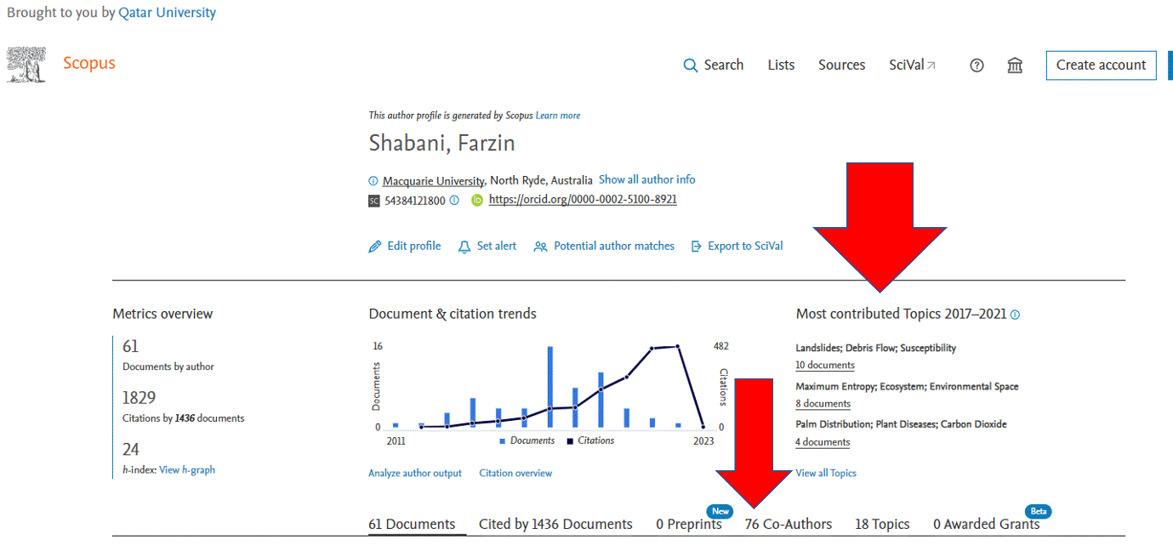

* It would be nice if Faculties from our Department could access it.
* It should be able to list all Grants, both national and international, obtained in the last three years
* This platform should enable us to highlight different faculty members outcomes at Qatar University.

|  |
| --- |
| We note that some of us can write a script (.py) that could collect the publication of all the faculty members from their google scholar, automatically and use it regularly, but it is more appropriate that these things come from IT people. |

**Aim 2:** CAS main website needs a Tab (a page) that lists all the achievements and events weekly. We (the HOD, Prof Sergio, I and a few more) must have access to it, so we should be able to announce our events etc, regularly. That link must be straightforward, and all the users (even those with minimal computation skills) should be able to work with it.

Time frame for Aim 1: we understand that this might take a few weeks, and it also depends on the IT’s workload, but we would appreciate it if you classify this as a **top priority** mainly because it will be used by 48 faculty members and this has been asked by the head of school.

Time frame for Aim 2: The sooner, the better. We can wait for the lunch of the new QU website, but since this is something easy to run on the current website, would appreciate it if you do it ASAP.